Assignment 4: News of the Day Formula Field in the Account object for IBM Vodafone using FF will redirect to BBC News search results

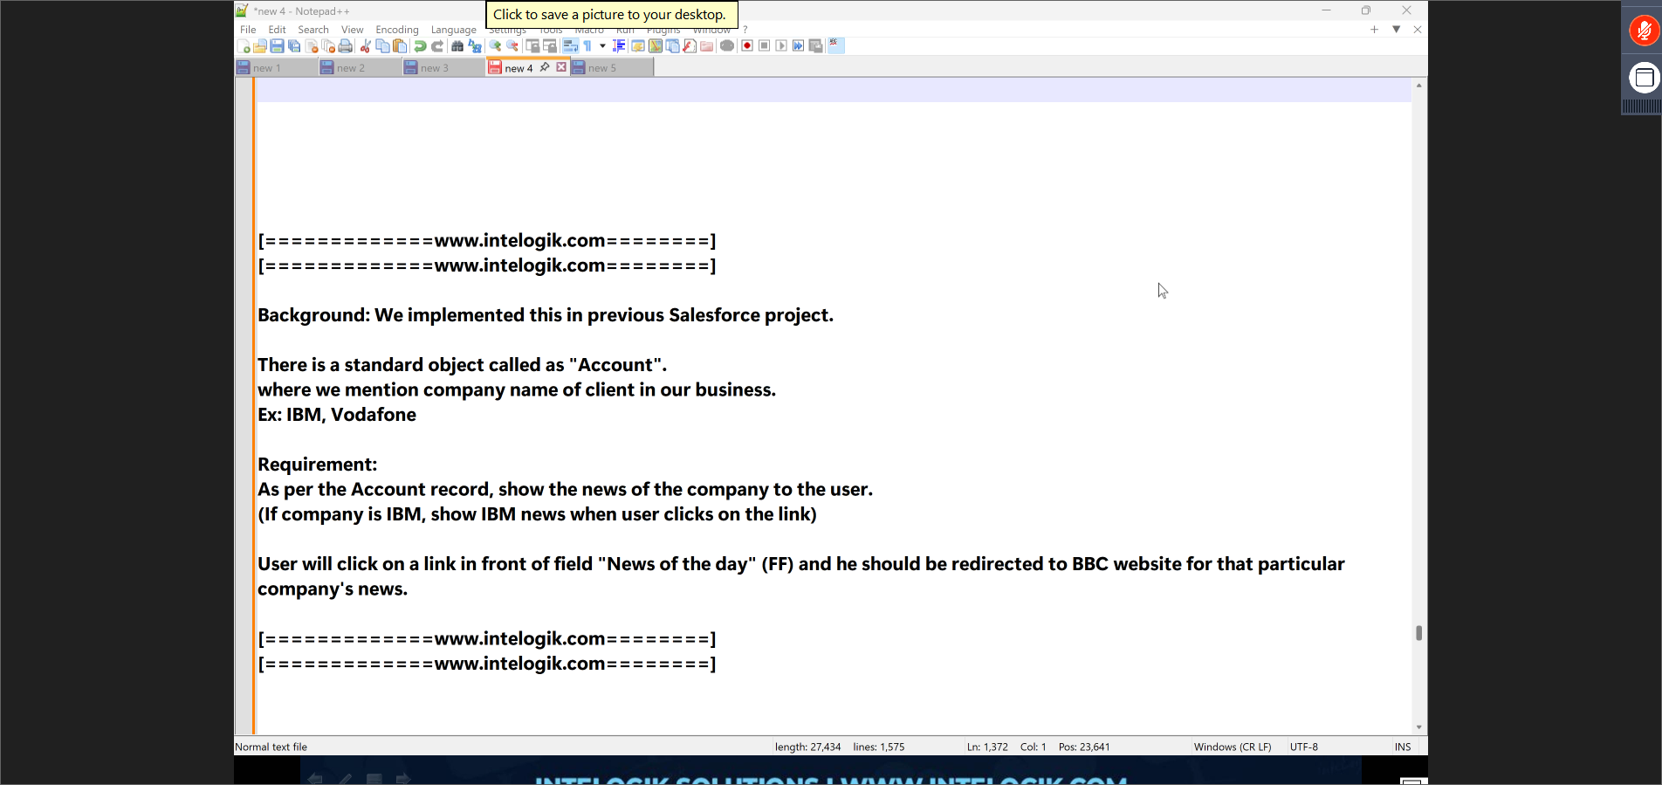
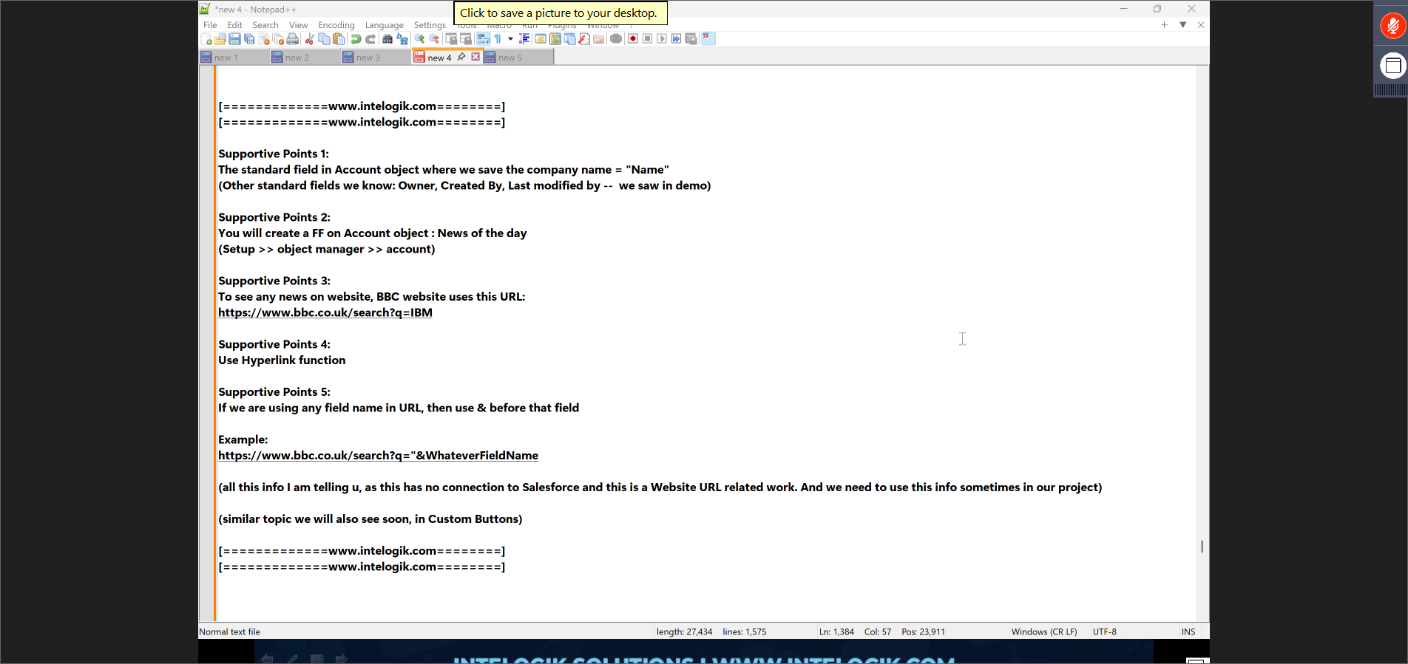

Step 1: Click on the settings gear and go to setup
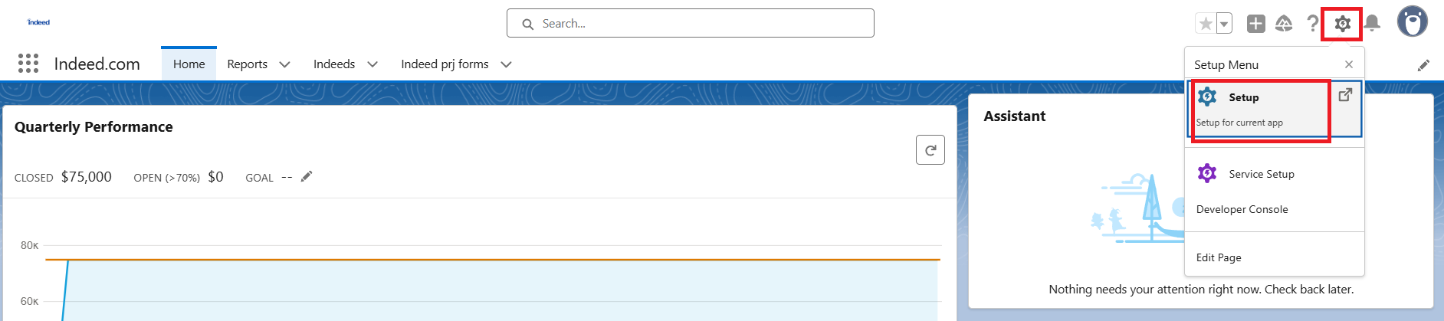

Step 2: Click on Object Manager and click on Account Label

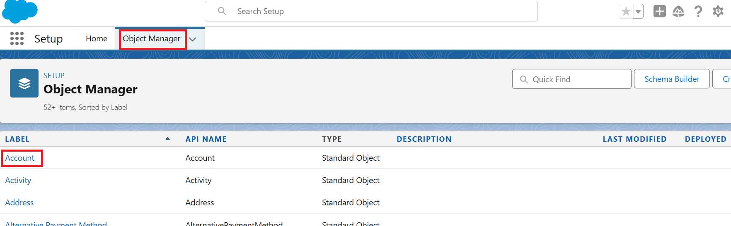

Step 3: Select Field & Relationships from the left pane and click on the New Button

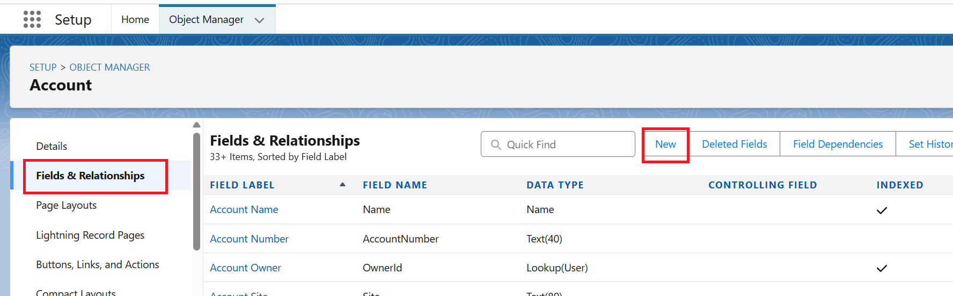

Step 4: Select Formula Data Type and click on the Next Button

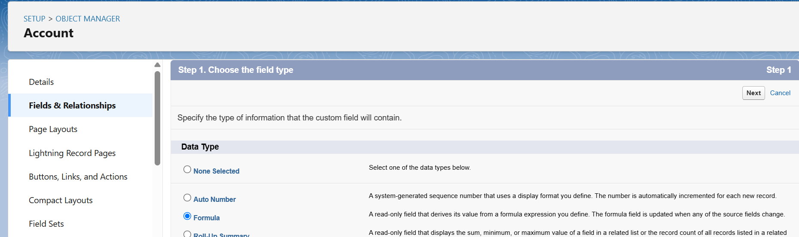

Step 5: Name the field Label as “News of the Day” and the Field name automatically populated, then select the Data Type as Text and click on the Next Button

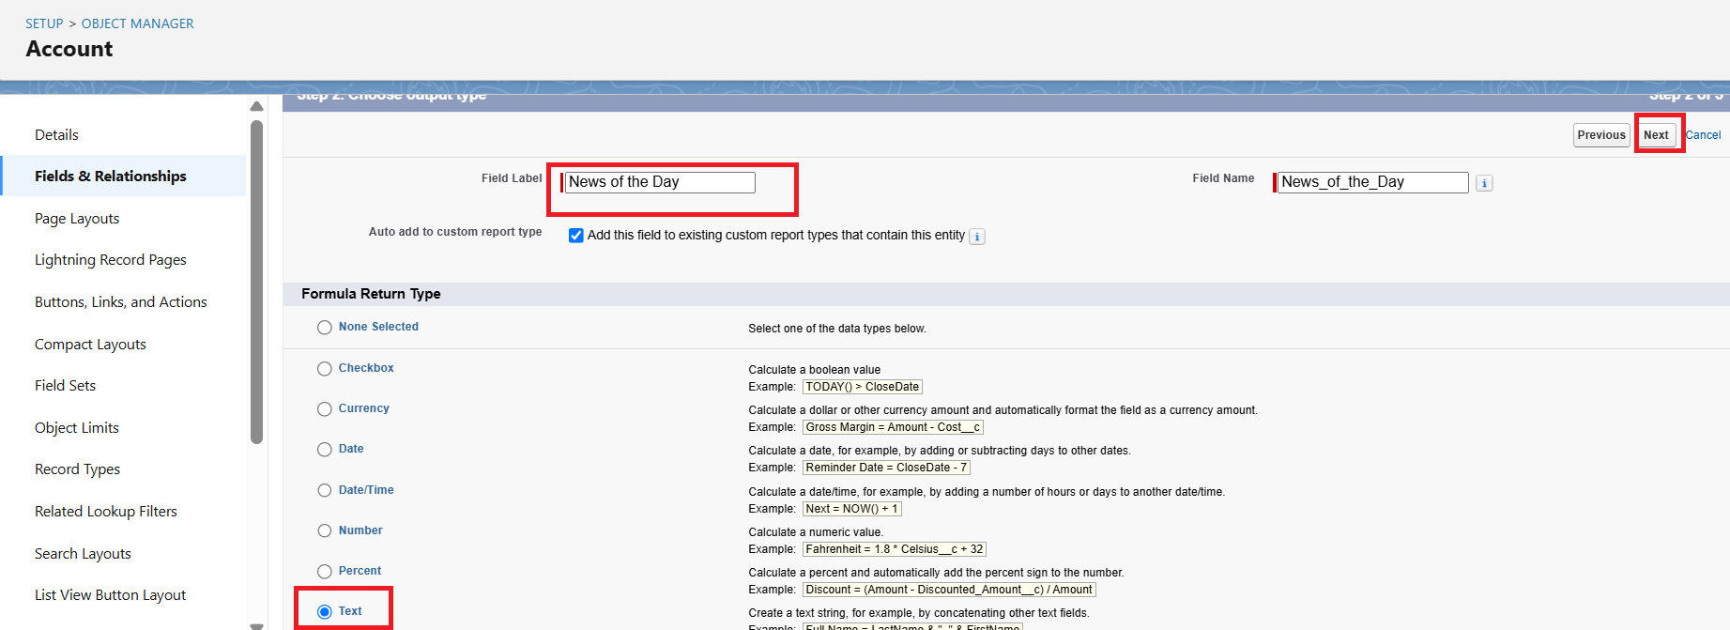

Step 6: Enter the Formula using the HYPERLINK function, Check Syntax for no errors, and click on the Next Button

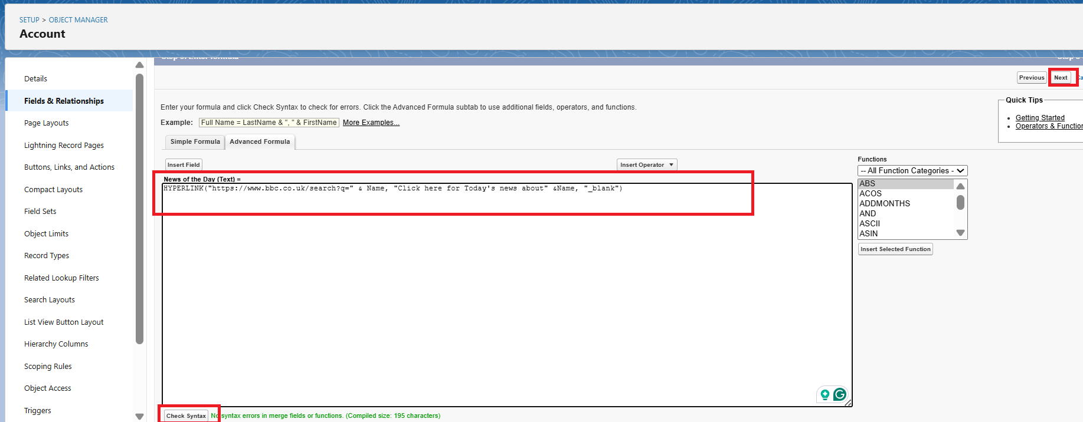

Step 7: Select the Read Access checkbox and click on the Next Button

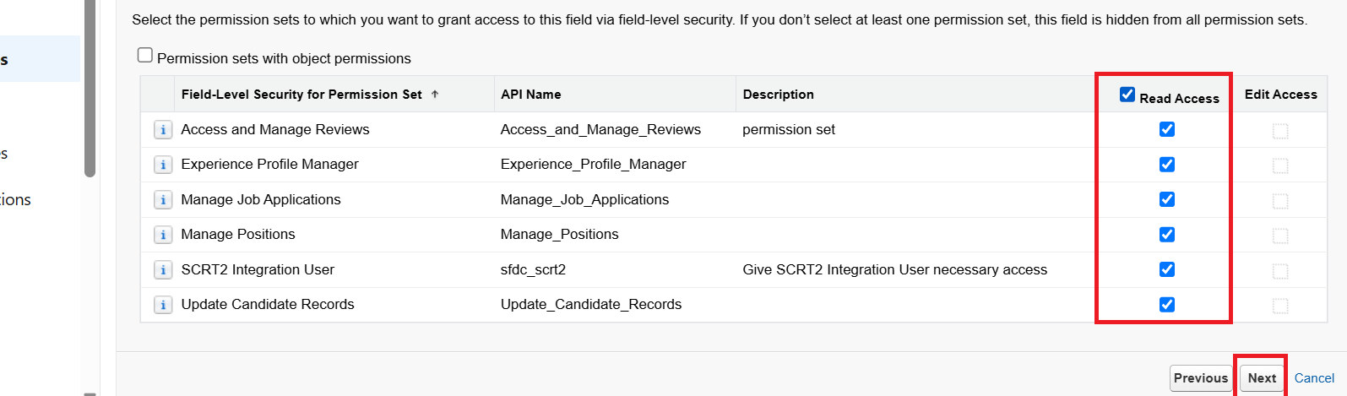
Step 8: Check the Page Layout Name and click on the Save Button

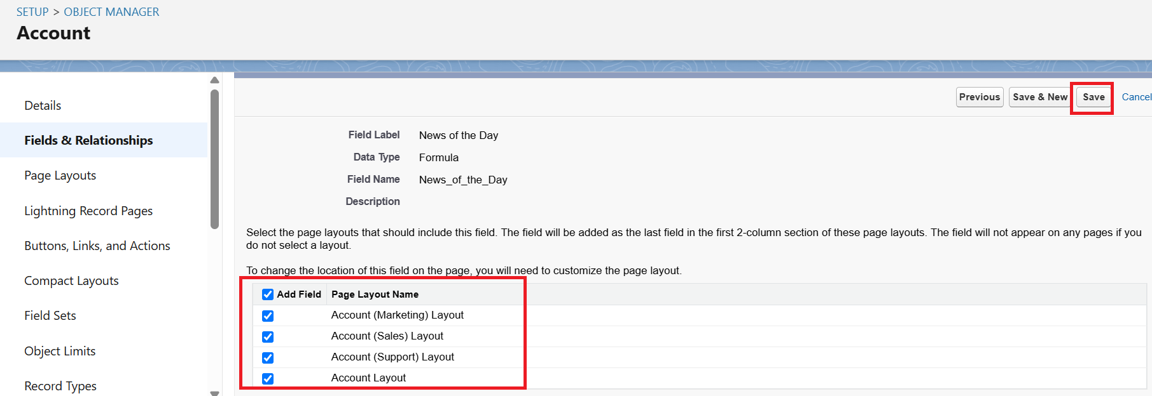

Step 9: The Formula Field, which is created, will be visible in the Fields & Relationships

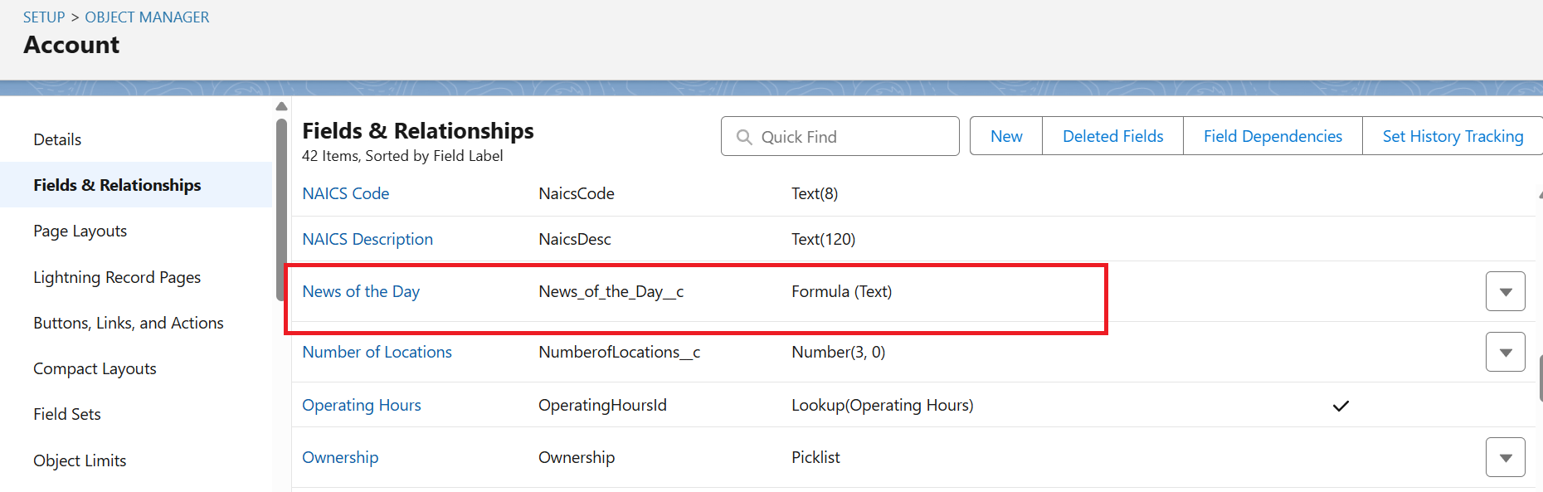

Step 10: Go to any Org Account Object and create a New Record for IBM and Vodafone accounts by clicking on the New Button and selecting the IBM account record

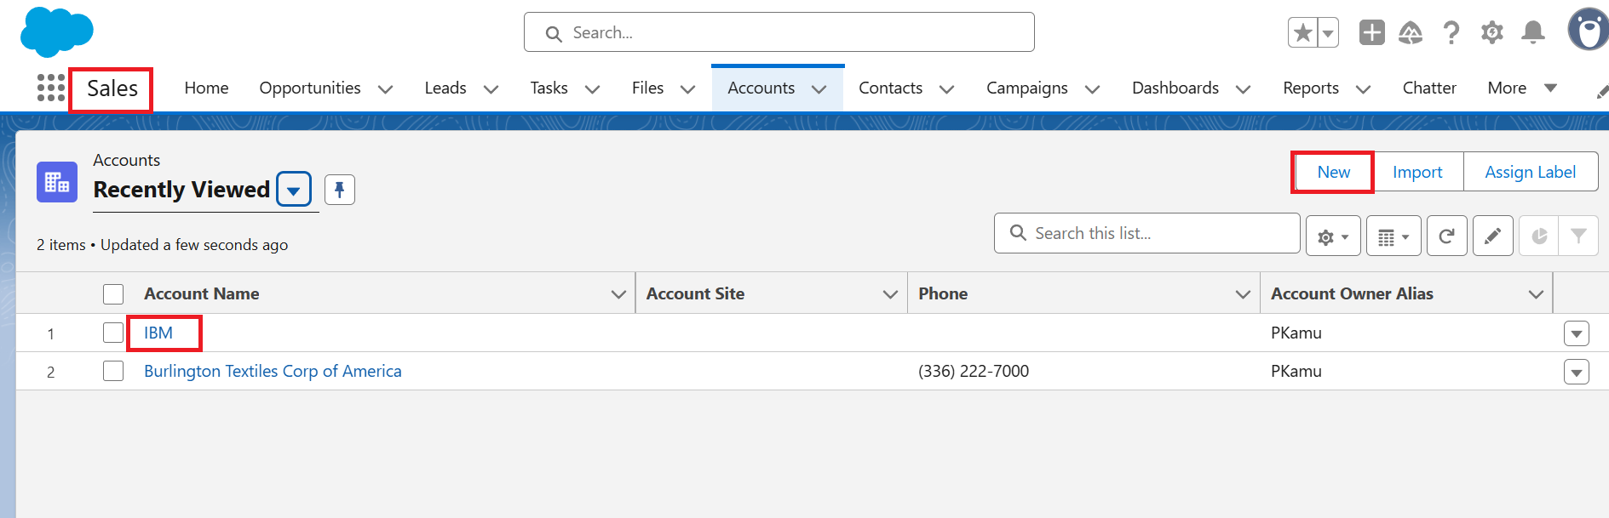
Step 11: Click on Details
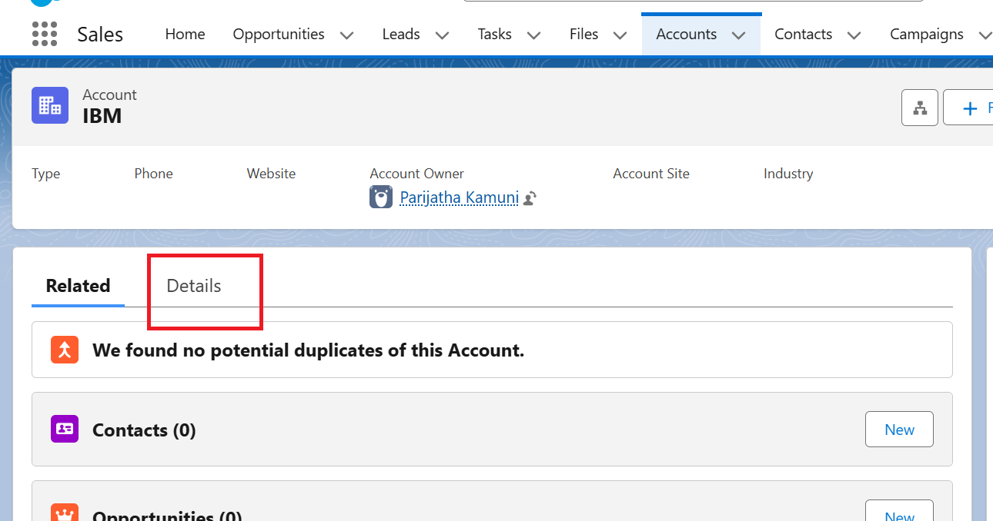

Step 12: Scroll down to see the “News of the Day” FF. Then click it, and it will redirect to BBC News search results for IBM.

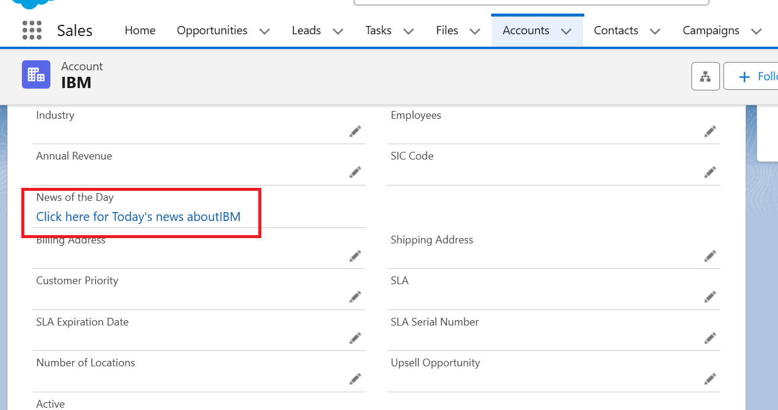

Result
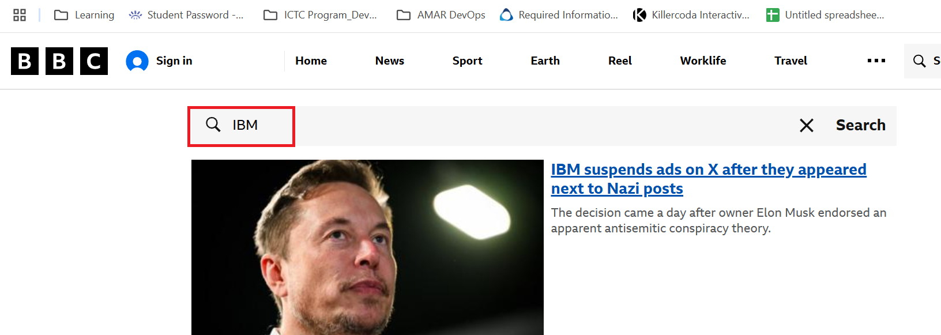

Step 12: Select the Vodafone account record, Then click on details and scroll down to see the “News of the Day” FF. Then click it, and it will redirect to BBC News search results for Vodafone.

